# Step 1: Download the Python Anaconda Distribution

Navigate to <https://www.anaconda.com/download/>

Download the version for you operating system (windows, linux, mac). **Get python 3.7.x. (the x means whatever the latest edition on the site is)**

# Step 2: Install Anaconda

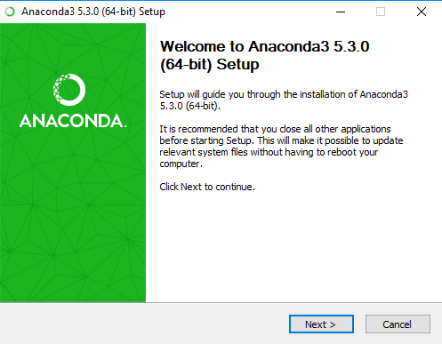

Setup prompt, your version may be different if the software has been updated since this screenshot.

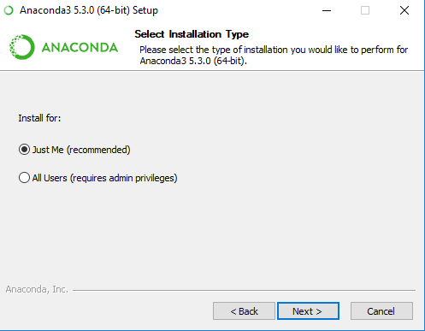

Make sure to install for just you if you don’t have admin access to your computer!

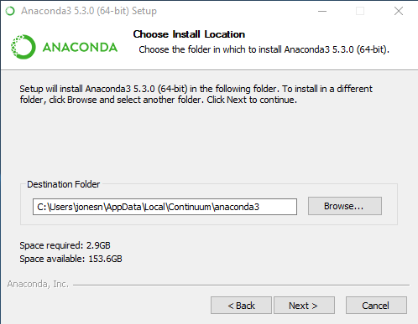

Verify that you have enough storage and use the default path for installation if possible.

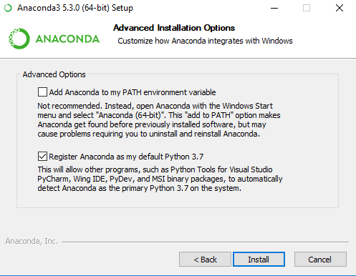

Select these options as shown. After navigating from this screen, anaconda will attempt to install. This will likely take 10-15 minutes. In class, we may work on setting up GitHub accounts while anaconda installs.

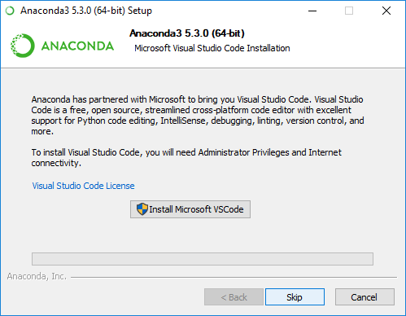

Installing VS code is optional and requires admin rights.

# Install git

Go to <https://git-scm.com/>

Download the latest version for your operating system

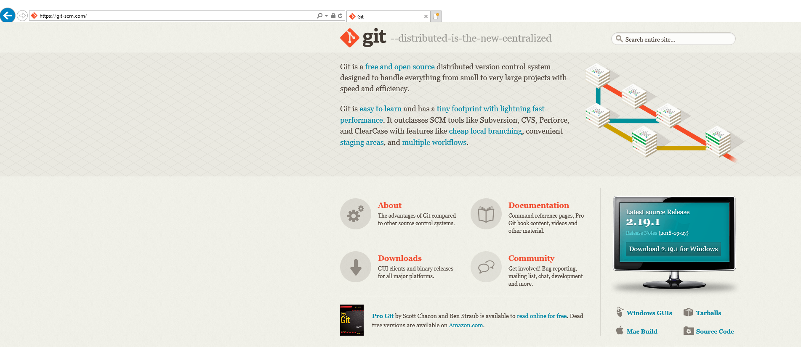

Install with everything default (there will be lots and lots of menus and options, just use the defaults for now)

# Create a github account

<https://github.com/>

Choose a username, type an email/password and click ‘sign up’

# Install Github Desktop

<https://desktop.github.com/>

Download and install github desktop

# ‘Fork’ the Class Materials and Pull Class Material Git onto your machine

Go to : <https://github.com/nathangeology/crc_python_crash_course>

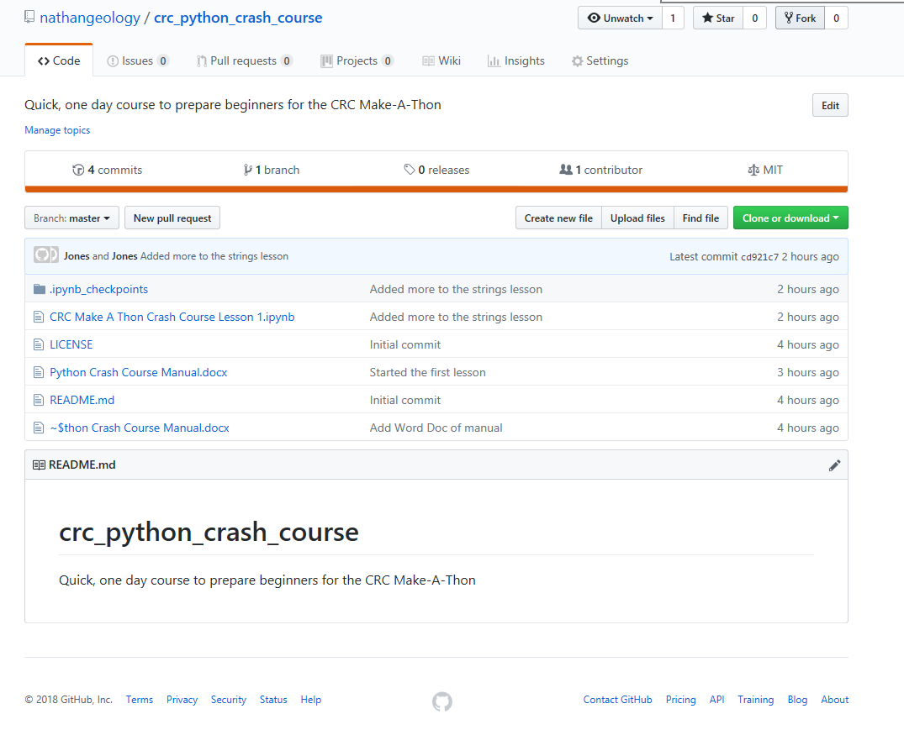

Click ‘Fork’ in the upper right corner of the page.

Add it to your personal repository.

Go to github desktop:

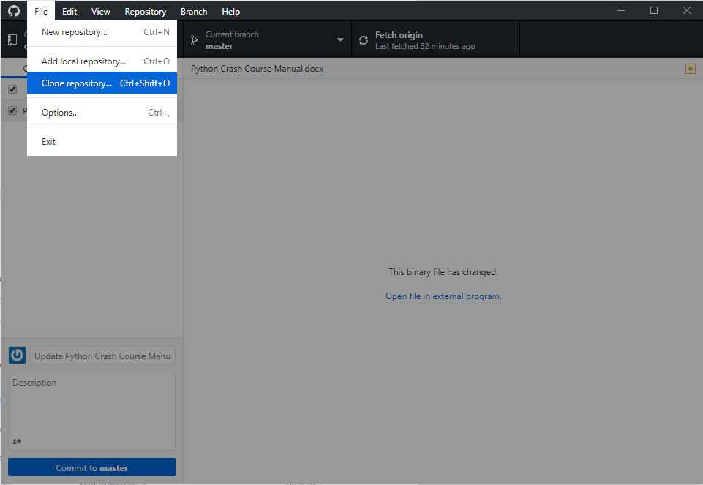

File-> Clone Repository

Select your fork of the class and clone it to your machine. We will use this repository later to do the class, but next we need to finish the setup of your python environment.

# Exploring Anaconda Navigator and setting up your python environment

Open Anaconda Navigator

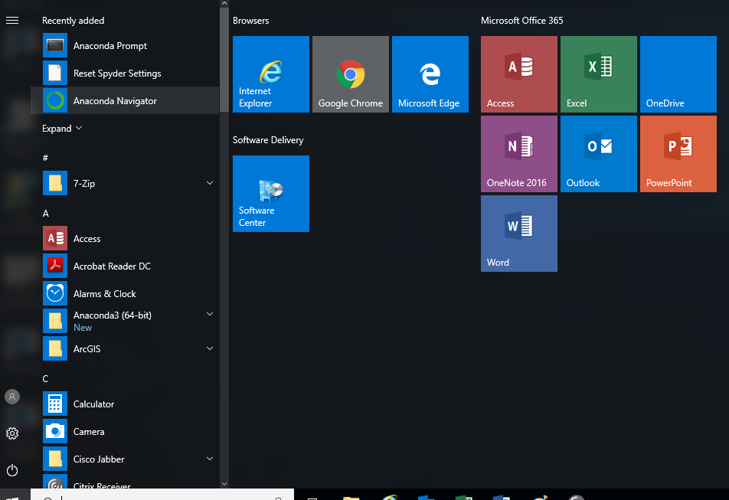

Open Anaconda Navigator

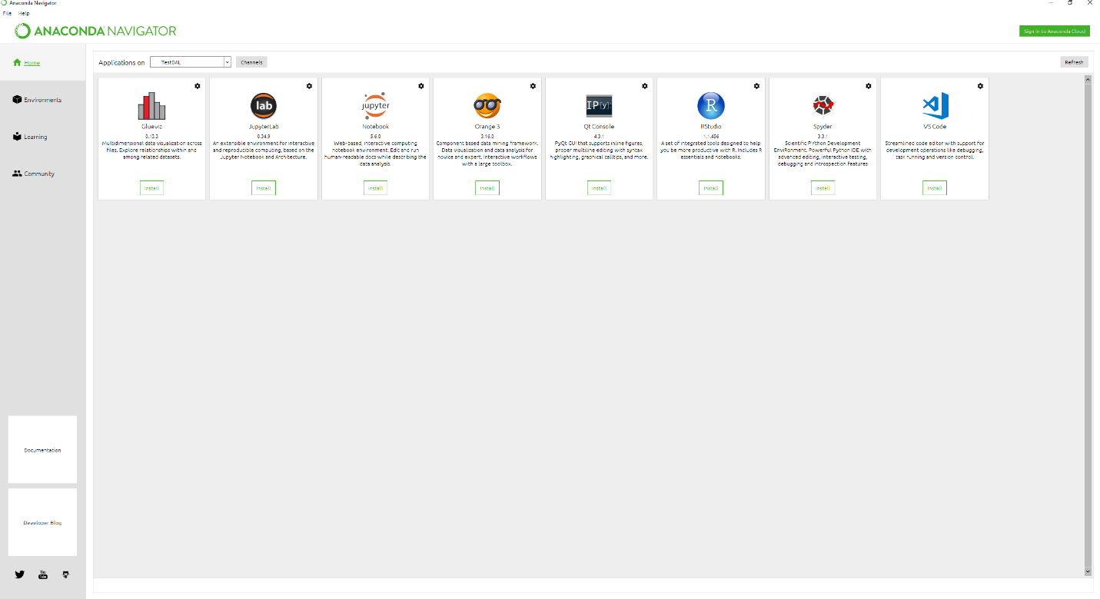

Clone an environment

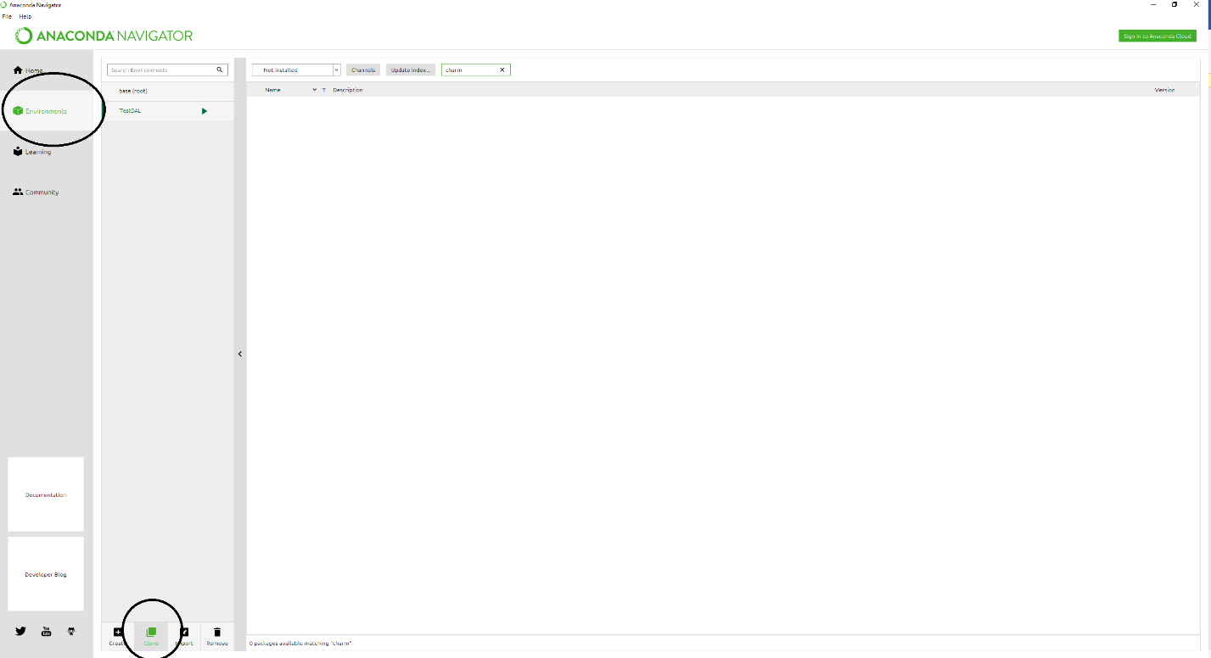

Install a new package in the environment

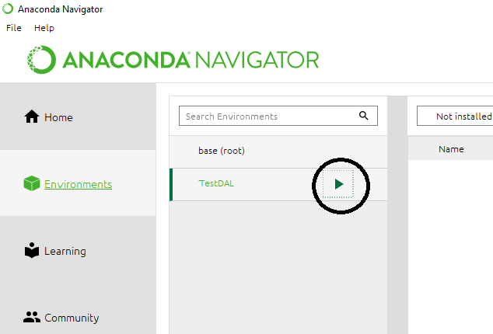

Click the arrow next to the environment

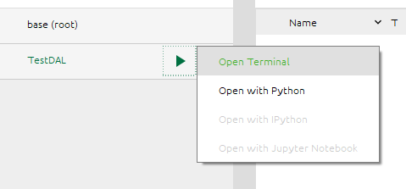

Select open terminal

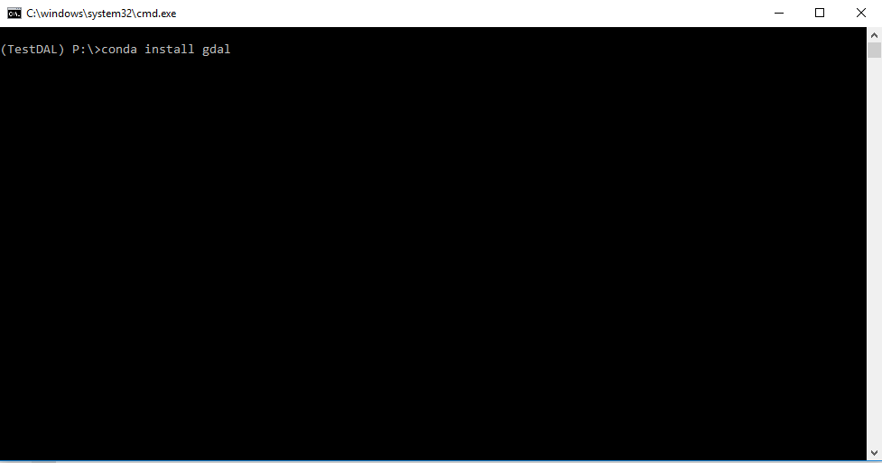

Type: conda install gdal

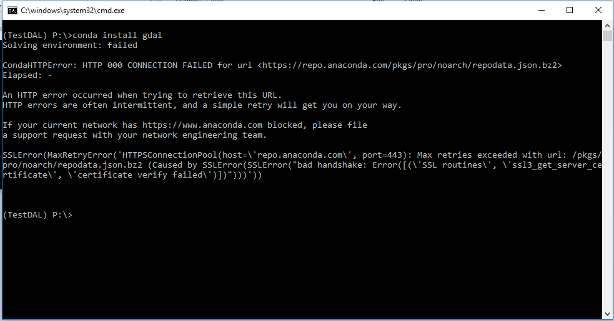

If you get this error type conda config --set ssl_verify False



Then type conda install gdal again. If you get an error on conda config, will need to have someone with admin access get you unstuck.

# Using the PIP installer to install a non-conda hosted package



Next type pip install altair

# Open the first lesson Jupyter Notebook in the class material

Navigate in the console to the folder where you ‘cloned’ the class material

If you need to change drive you can use:



C:

The default path for github desktops is you documents folder so you would type

cd users/<your username>/Documents/GitHub/crc_python_crash_course



Launch jupyter notebook by typing ‘jupyter notebook’



# Manipulating Text

Open the 1st lesson notebook from the jupyter notebook startup screen in the browser

